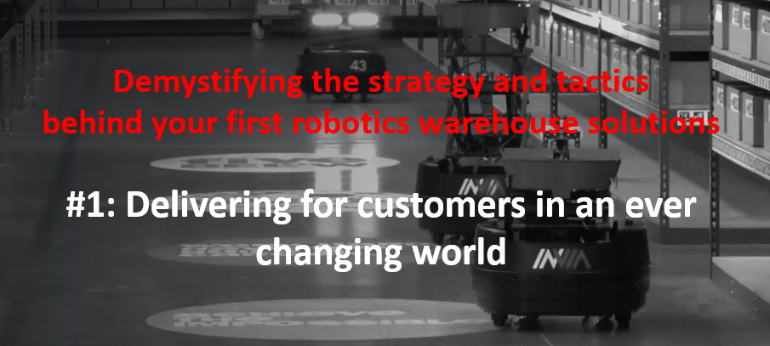

Automation is no longer ‘nice to have’, it is fast becoming a necessity.
According to Gartner, by 2026, 75% of product-centric businesses will have adopted some form of intralogistics smart robots in their warehouse operations. In the main this is because businesses are trying to optimise their labour model.
WHY, WHAT, HOW, COST?
However, with the introduction of Autonomous Mobile Robots (AMRs), whilst cost is now less of a barrier to adoption, one challenge users face is that there are almost too many options given the large diversity in AMR platforms and use cases. Companies are left with trying to determine which are the right platforms to pursue, but because most companies lack experience, this is slowing adoption.
AMR Supply Chain’s series of 3 webinars attempts to help companies navigate their way through the warehouse automation landscape – and this blog focusses on the key take-aways from our first webinar – Delivering for customers in an ever changing world.
In this webinar we were delighted to hear some global supply chain insights from Professor Edward Sweeney (Professor of Logistics and Supply Chain Management at Heriot-Watt University) and the sharing of her experience in delivering robust warehouse automation solutions from Lauren Ziccardi (VP Solutions for the Gartner award winning inVia Robotics).
Addressing 21st century Supply Chain Challenges through Digitisation
Mega Supply Chain challenges
Supply Chain Management and Logistics has never had a higher profile. Over the past 5 years, it has been very much centre stage in political debate and media discourse, often because of specific challenges and problems.
Going forward, there are a number of existing and new ‘mega’ Supply Chain challenges facing us – challenges which cut across sector, exist at different points in the chain and are global.
Competition and markets
The single biggest challenge is still competition – all of us work in intensely, or Hyper-competitive markets. We are trying to satisfy customers in markets that are becoming more and more sophisticated and discerning, putting downward pressure on the prices we can charge.
Cost pressures
Along side this we are seeing the well documented cost of living pressures – particularly in terms of fuel and labour costs. How do we deal with these?
Talent challenge
One of the reasons for the labour cost problem is that we have this talent challenge – well documented talent shortages in many parts of the supply chain. The effective deployment of robotics and other advanced technology is completely dependent on talent. You can’t talk about talent and technology separately.
The need for resilience
If we have learnt anything these last three years, brought on specifically by the pandemic, is the need to build in resilience upstream and downstream. An example of this is a shift from ‘just-in-time’ to ‘just-in-case’ where holding stock at strategic points in the supply chain has become much more common.
International economic and political volatility
The biggest single change over the past thirty years has been the move from regional to international and global supply chains, leaving us subject to the volatility that goes with that. The logistics sector has been at the vanguard of having to deal with the fallout from Brexit, and more recently the Ukrainian war.
Environmental degradation
There is no doubt our supply chains damage the natural environment, particularly with their greenhouse gas emissions. Consequently, there is a strong focus now and in the future on doing things, not only more efficiently and effectively, but also in a more sustainable fashion.
VUCA
To grapple with one of these challenges is hard enough – to have to deal with all of them simultaneously is a major issue, but one that we have no option but to address.
The VUCA concept is not new but has never been more apposite then now. Our ‘New Normal’ is Volatile, Uncertain, Complex and Ambiguous – the latter being most interesting as we now live in a world where there is no rule book or case studies to work from.
The Opportunity
The good news is that there is a massive opportunity for all of us. The critical economic and societal role of logistics and supply chain has never been more clearly recognised, and that creates a massive opportunity for all of us.
What do we need to be doing is putting contemporary SCM thinking into practice i.e., replacing the traditional fragmented processes by doing things in a much more joined up and integrated fashion.
The key word here is Innovation, recognising that whilst technology and digitalisation are critical enablers to innovation, people and learning are critical success factors.
Effective technology deployment and smart digitalisation is the route to:
- Visibility
- Integration
- Resource optimisation
- Agility and responsiveness
- Resilience and sustainability
All of these things are important across the supply chain, but the greatest potential lies in the warehouse.
Learning from the past
Going forward we must not repeat the sub-optimal approaches of the past e.g.
- Failing to identify the real problems
- Tackling problems in isolation without looking at the interactions
- Copying inappropriate solutions – just because something works in one context, it doesn't mean it is going to work elsewhere
- Automating bad processes – resulting in a ‘slightly faster’ bad process!
We have, perhaps inadvertently created a digital divide in supply chains; we see the relatively few large companies powering ahead with investment in innovation and digitalisation, whilst their SME partners don’t invest for a number of reasons. We must remember that in most supply chains the SMEs are the backbone, and many of these are struggling with low/unsustainable margins and little opportunity to innovate.
A supply chain is only as good as the weakest link.
There is also no magic solution, despite what technology vendors might tell us.
The way forward
Standing still means going backwards. So, to create the resilient supply chain of the future, we will have to adopt a strategic, holistic systems thinking approach with a focus on integration.
Technology and infrastructure will play the critical ‘Hard-wiring’ role, but the ‘soft-wiring’ (people and learning) will be as equally important. Successful companies will manage to bring these two together in a seamless fashion.
The other thing that is important is ‘info-engineering’. We are now collecting large amounts of data that needs to be converted to information that can help with decision making.
Finally, we need to address the digital divide – looking at and involving the extended enterprise.
………………………………………………………….
Warehouse optimisation is key in our new multi-channel world
Looking now at the more micro level challenges facing warehouses, these stem from the fact that historically, warehousing and warehousing software solutions were built on the premise of moving large quantities of items and fulfilling retail stores on a regular, predictable basis.
Purchasing behaviour has changed with many more people now ordering small quantities online from a much wider range and demanding fast delivery. This in turn has accelerated (aided by rising fuel costs) the move towards the placement of inventory in ‘micro-fulfilment’ centres.
The evolving fulfilment technology landscape
The need to optimise warehouse efficiency, solve the problem of random access to inventory and meet the increasingly demanding expectations of the customer has led to a fast evolving technology landscape focussed on fulfilment – the action of servicing your customer.

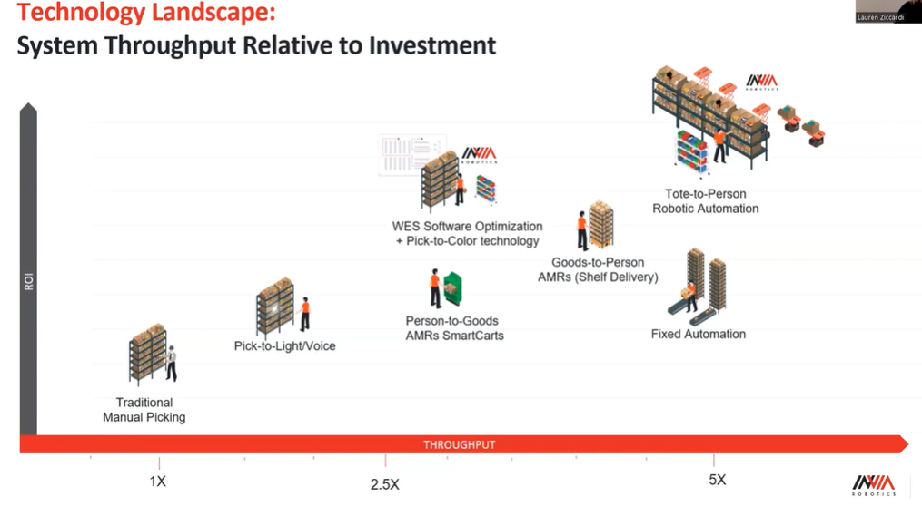
Until the advent of the Autonomous Mobile Robot, which significantly reduced the cost of deployment, the best solution was probably the fixed-automation solution. However, these solutions are very expensive and beyond the financial reach of all but a few companies.
It is not only the cost that is the issue with the fixed automation solutions, but also the time involved to set up and realise the benefits, and the flexibility to react and adapt to change in our new VUCA normal.
The fulfilment automation decision is about getting the right balance between productivity gains, flexibility, sustainability, speed of deployment and cost. What is good enough for today, whilst not restricting your ability to adapt in the future.
The inVia Robotics mobile goods-to-person solution at the top right of the above chart represents a new blend of the various technologies we have had over the past few years. The robots go out into the facility for the order and retrieve the item required for your order and bring it to a central location, to make the person picking a lot faster. This ‘decoupling’ of robots from human processes can maximise productivity gains.

The solution to the labour situation
With major challenges in hiring and retaining labour, does it make sense to pay the 60-70% of labour in a warehouse environment who are dedicated to picking and packing, then to spend about 70% of their time walking?
Automating that walking can dramatically reduce costs and help retain the talent you need. For example, the inVia Robotics solution delivered a tenfold increase in pick rates when implemented in a leading manufacturer of components for industrial applications.
Just one of the reasons inVia Robotics was named as Gartner’s Cool Vendor 2022 for mobile Goods-to-Person Technology.
……………………………………………………………………
Conclusion
In summary, in our new normal’, smart and sustainable supply chain logistics in the future will need to be globally connected, customer-focussed, environmentally sustainable and structurally resilient.
This will be facilitated by effective technology deployment/smart digitalisation, with the greatest potential lying in the warehouse and fulfilment process.
The evolving AMR market brings the automation solution within the reach of the SME sector, but it is important to understand which of the various solutions is right for your business.
………………………………………………………………….
Webinar #2: Creating the warehouse of the future
Join us for the second webinar in our series on the 16th February 2023, where Clare Bottle (Chief Executive of the UK Warehousing Association and Adam Conner (Enterprise Sales Director – inVia Robotics) will talk in more detail about the benefits of warehouse automation, comparing the pros and cons of the various solutions and using real case study examples.
Gain a competitive advantage
If you want to be at the forefront of fulfilment automation and are interested in learning more about the inVia Robotics solution, please email me at Paul.brooks@amrsupplychain.com
AMR Supply Chain is the exclusive UK/EU partner of inVia Robotics.

