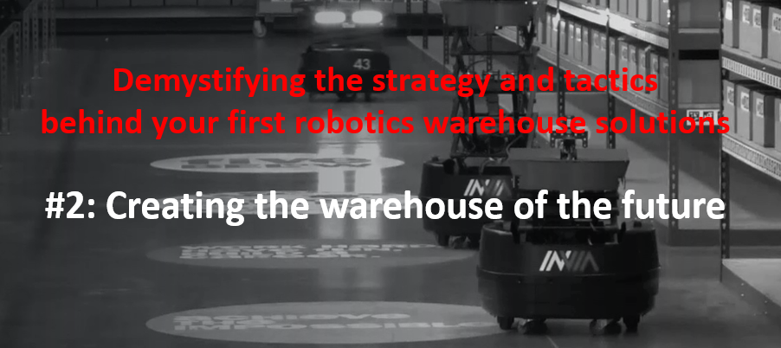

Automation is no longer ‘nice to have’, it is fast becoming a necessity.
According to Gartner, by 2026, 75% of product-centric businesses will have adopted some form of intralogistics smart robots in their warehouse operations. The primary reason for many being labour restraints.
WHY, WHAT, HOW, COST?
However, with the introduction of Autonomous Mobile Robots (AMRs), whilst cost is now less of a barrier to adoption, one challenge users face is that there are almost too many options given the large diversity in AMR platforms and use cases. Companies are left with trying to determine which are the right platforms to pursue, but because most companies lack experience, this is slowing adoption.
AMR Supply Chain’s series of 3 webinars attempts to help companies navigate their way through the warehouse automation landscape – and this blog focusses on the key take-aways from our second webinar – Creating the warehouse of the future.
In this webinar we were delighted to hear Clare Bottle’s (CEO UKWA) views on the warehouse of the future, and details of how the inVia Robotics solution can overcome some of the constraints…. from Steve Doster (Senior Enterprise Sales Director – inVia Robotics)
The future of warehousing
The advent of automation 2.0
UK warehousing has seen massive growth (covered space) of around 50% in the last 5/6 years. This has been driven by change in the supply chain at both ends.
On the one hand you have quasi-manufacturing activities such as Amazon printing T-shirts, or DHL filling boxes of sweets inside a warehouse rather than a manufacturing facility.
On the other hand you have this massive growth in e-commerce replacing business that was traditionally done in retail stores. So things that would have been done in a retail outlet are being pushed up the supply chain e.g. carefully wrapping things in tissue paper, personalising them and providing information like leaflets
Lots of growth but this is placing pressure on increased labour shortages (a worldwide problem) which is a particular issue in the UK with Brexit (36% of our forklift drivers used to be of EU nationality and many are no longer here).
This pressure led us all to look more closely at how to automate in order to make the best use of the labour available.
Historically the people who had automation were the big companies like John Lewis, RS Components etc., who could afford to take a long-term view on ROI.
11 years ago, Amazon bought Kiva and that signalled a change as other companies realised that a ‘different’ sort of robotics solution might be more useful in warehouses.
One ‘size’ doesn’t fit all
Automation is sometimes put across as a conflict between ‘big, fixed robots’ and the smaller AMR robots.
The reality is you can have both – a prime example is the GXO/Nestle warehouse which has 5/6 different automation solutions in it. Some of the solution, therefore lies in weaving these solutions together.
At the recent UKWA conference, the point was made that the UK labour cost of picking was higher than average. This and related labour hungry activities will see a lot of growth in goods to person automation solutions.
There is already quite a bit of activity in this area, but largely limited to big sites dedicated to one customer. 80% of UK warehouses still have no automation, so there is enormous potential still.
We are also now seeing more interest in the idea of RaaS as lowering the cost and risk of entry.
Another consideration is the interface between people and robots. One area is safety, which is leading to solutions that have segregation.
The other, very interesting area is skills. What skills will people need to have to work with robots and how do they feel about it. Digital literacy is probably the most important than the outdated functional skill requirements.
Where will the value of a 3pl really lie
Traditionally it would be in their ability to manage large numbers of people.
In the future it might be about their expertise in fitting the right kind of robotics solution to the needs of their customers, and also about the IP of the ‘middleware’; how different systems speak to each other. Easy to be beguiled by the beauty of a robotics solution, but robots are only useful if they know what to do.
So leaders need to know what they expect to get out of a robot, and secondly the robots need to know what they are expected to do. You need some kind of system to be able to do that.
Solar and power
With more automation and the drive to Net Zero, there is a need to do something different.
It is a real disappointment that only 5% of warehouses in the UK have any solar panels. And if they do, it is only 10-25% of the roof space that is covered.
We are getting there with the XXstandards for new builds, but there are plenty of retro fit opportunities to unlock.
With forklift trucks there has been a major shift to battery powered units as technology has developed, and there will inevitably be a growth in autonomous vehicles within the warehouse space. Where will the extra power required come from? So far no government initiatives mentioned in the spring budget re solar panels, which is a real disappointment.
Solar should be a prerequisite of future warehouse specs. Many UKWA members won’t be interested in properties w/o decent power supply (e.g. solar).
Getting software to talk to each other
One of the real challenges in creating the optimal warehouse is getting all the different software to talk to each other. This is a real opportunity for value add and will impact significantly on the productivity improvements you can achieve.
From a 3pl perspective, there is the risk of giving too much value away by allowing systems integrators to do all this. They should seek to retain some IP in this area.
The inVia Robotics’ approach
The issue with many automation solutions to date is that they are purely hardware solutions.
They bring a lot of technology around an activity e.g. picking or sorting, but it is left to the owner of the warehouse to utilise these investments to best effect.
This is where inVia Robotics’ strategic approach, enabled by its main funders (Microsoft, Qualcomm and Hitachi) differentiates itself.
- AI driven software
With many of the software solutions within a warehouse currently, all of the functionality is being manually directed. That carries over to the operator who has to decide how to respond to the many common issues which arise during their daily job.
A lot of manual decision making that has a huge impact on productivity.
inVia does offer a Goods to Person robotics solution, but what lies underneath this is a unique powerful algorithm that helps orchestrate all the movements and dependencies of both people and robots – optimising the flow within a warehouse (e.g. picking and replenishment), avoiding bottlenecks and ensuring the most orders per day.
- Minimal infrastructure impact
The inVia solution is the only one that can exist within brownfield sites, utilising existing flooring and racking. Flexibility, scalability and speed of deployment (and redeployment) are key considerations for most businesses taking their first step into the world of automation. inVia delivers in all these areas.
- Cashflow
inVia’s RaaS model not only reduces the cost of entry into automation, but it also means inVia is engaged with the client on a daily basis. The client is paying for productivity – inVia ensures that that productivity is delivered on a daily basis. Its Remote Operations Centre (ROC) runs 24/7.
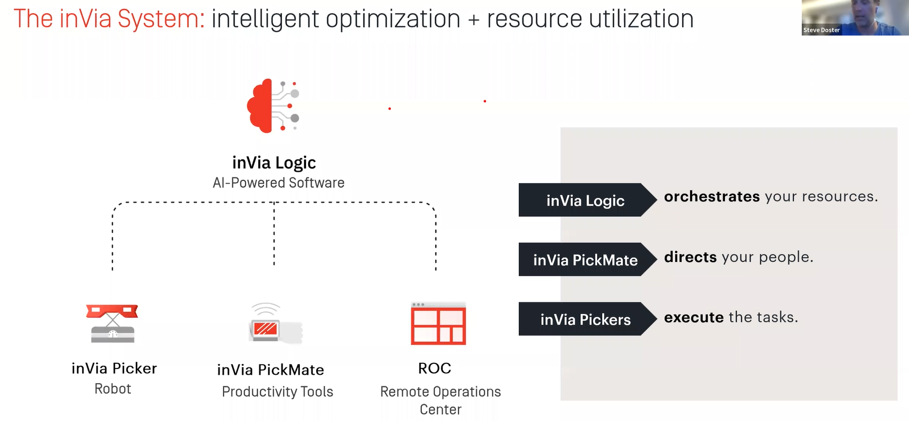
Warehouse operators are experts at distribution and fulfilment – inVia looks after the robotics.
The technology landscape
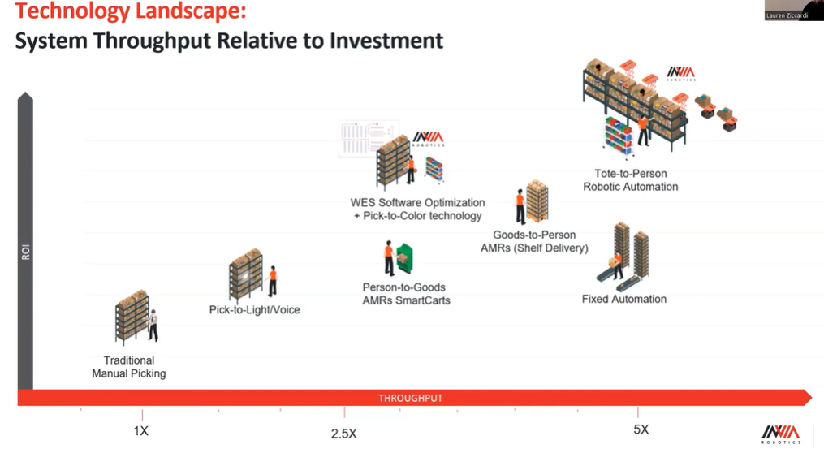
Different profiles mean that not all automation solutions are appropriate.
The above chart shows all the technology/hardware solutions available currently. Working from left to right, you see the productivity gains as well as the RoI.
Not surprisingly the Fixed Automation solution has traditionally delivered the highest productivity gains, but at a high cost and offers little flexibility to cope with the ever-changing environment in many operations.
The inVia solution has the ability to deliver similar productivity gains, but with a lot more flexibility. It represents a new blend of the various technologies we have had over the past few years. The robots go out into the facility for the order and retrieve the item required for your order and bring it to a central location, to make the person picking a lot faster. This ‘decoupling’ of robots from human processes can maximise productivity gains.
inVia also offers a standalone software solution (inVia Logic) that, instead of directing robots, it directs people to pick orders. It uses its unique IP and Pick to Colour technology to minimise travel.
The productivity gains from just deploying inVia Logic can match or exceed those realised by current Person to Goods AMRs.
inVia Logic is modular, optimising tasks across the fulfilment process, not just picking.

Changing the culture
Instead of sending waves of orders and sending people to multiple locations throughout the day, inVia are taking the commonality of all the orders and grouping them on a cart so that travel time is significantly reduced.
To avoid people having a mundane, methodical type of motion, inVia loves to burst through things. People can then undertake greater value added tasks whilst the robots continue their activity.
inVia’s patented PickerWall decouples people from robots and allows them work most efficiently in bursts and rotate freely across other warehouse tasks whilst the robots continue their work 24/7.
In other words, the inVia solution can change the entire culture within a warehouse, improving job satisfaction and increasing staff retention.

Conclusions
Labour costs and the availability of labour are ongoing issues for warehouses.
Automation can help to address both of these, and with the advent of automation 2.0, more flexible and affordable solutions are now available. However 80% of warehouses have yet to embrace automation.
Every physical supply chain has warehousing in it – handling a huge variety of products. Consequently there is no one automation solution that fits all. For a lot of companies automation is seen as complex and high risk often phrasing this as ‘my warehouse isn’t right for automation’.
However, the opposite is true, especially with the RaaS solution, as there are plenty of opportunities to ‘try’ automation in an area of a warehouse at relatively low cost and risk.
Companies will find that they can fix some of their bigger problems quickly by focussing on those first, rather than trying to ‘design for perfection’.
inVia offers a CRAWL – WALK – RUN approach enabling a company to start small with software and scale up as and when it makes sense. For example they have one start-up 3pl who has a 5,000 sq ft robotics area – used to demonstrate to potential clients the benefits of automation.
This approach also helps with managing the culture change transitioning from a ‘paper based’ operation to a ‘robotics’ environment – which can be very intimidating.
Be braver and try things out is the way forward..
………………………………………………………………….
Webinar #3:
Join us for the third webinar in our series in March where using case study material we will unpick and unpack the options for warehouse automation.
Gain a competitive advantage
If you want to be at the forefront of fulfilment automation and are interested in learning more about the inVia Robotics solution, please email me at Paul.brooks@amrsupplychain.com
AMR Supply Chain is the exclusive UK/EU partner of inVia Robotics.

