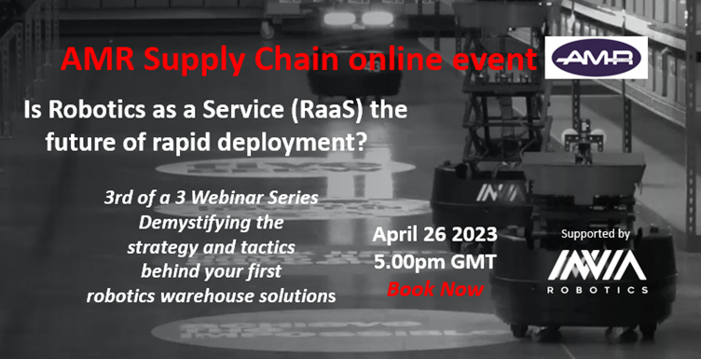
Automation is no longer ‘nice to have’, it is fast becoming a necessity.
According to Gartner, by 2026, 75% of product-centric businesses will have adopted some form of intralogistics smart robots in their warehouse operations. The primary reason for many being labour restraints. However, currently some 80% of warehouses in the UK do not have automation.
WHY, WHAT, HOW, COST?
With the introduction of Autonomous Mobile Robots (AMRs), whilst cost is now less of a barrier to adoption, one challenge users face is that there are almost too many options given the large diversity in AMR platforms and use cases. Companies are left with trying to determine which are the right platforms to pursue, but because most companies lack experience, this is slowing adoption.
AMR Supply Chain’s series of 3 webinars attempts to help companies navigate their way through the warehouse automation landscape – and this blog focusses on the key take-aways from our third webinar – Is Robotics as a Service (RaaS) the future of rapid deployment?
In this final webinar Kurt Nantkes (Chief Revenue Officer of inVia Robotics) explains how RaaS works and its benefits, and Phil Regan (Co-Founder of AMR Supply Chain, the UK and EU partner of inVia) explains AMR’s role in helping companies deploy inVia’s software and robotics solutions.
Kurt Nantkes
The warehouse operations challenge in numbers.
In 2020, nearly 300m EU consumers shopped online, a trend accelerated by Covid. In the midst of that growth there was a dramatic increase in SLA expectations – 90% of consumers now expect 2-3 day delivery, and 85% would switch supplier if their delivery times were not competitive.
Meeting SLA expectations is a function of labour, the shorter the SLA time frame, the more labour you need. However, 73% of warehouse operators cannot find enough labour – it is not seen as an attractive role – repetitive and hard on the body.
The result therefore being c40% of operators are having to rely on temporary staff to fill gaps.
In addition, companies are having to pay more to attract and retain staff – pushing up the cost of fulfilment by c20% over the last year.
Automation is now being increasingly recognised as the solution to these challenges.
The Warehouse automation solution options
Automation solutions fall into 4 ‘Buckets’ – inVia Robotics being in the first one below.
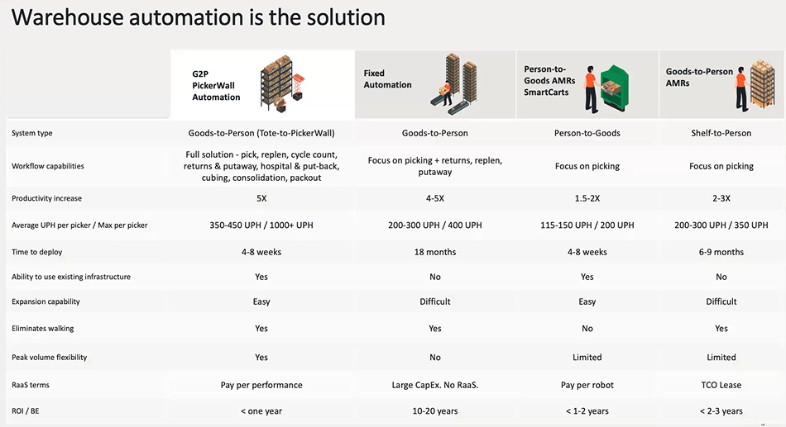
All of these options have their own benefits (or secret sauce), therefore when evaluating automation, companies should focus on the following criteria:
- What type of system are you looking for – Gods to Person (G2P) or Person to Goods (P2G)?
- What are the workflow capabilities that come with a system – you can optimise your picking, but if you don’t have productivity improvements in packing and replenishment, you are just creating a bottleneck somewhere else. You need to look at what other software automation systems can be bolted on to ensure optimisation.
- RoI – what is that productivity increase that you are going to get from the system? inVia measure this in terms of units (or lines) per hour on an individual FTE basis. At this measure the inVia system significantly outperforms any other system.
- Time and cost to deploy is another key consideration – with fixed automation there really is no opportunity for quick RoI due to high capital costs. However, AMRs have changed the dynamics of the decision-making process with their lower cost and shorter deployment timescales resulting in much faster paybacks. The most impact has been in the 3PL sector, where previously they have not been able to automate as most contracts are too short to deliver a payback. Now they can invest in confidence, knowing that payback is within the timelines of a contract.
- Does the system operate within your existing infrastructure, or do you essentially have to rip everything out and start again, giving you potential time or cost issues. G2P tote systems and P2G smart carts can work with existing structures, enabling deployment in brownfield sites, whilst fixed automation and shelf to person systems can’t and don’t.
- How easy is it to expand or deal with peak volume periods? We know volume changes over time and really you shouldn’t be investing in automation unless you expect growth. With fixed automation you are having to build for the future/peak period now and paying for it now. With smart carts and inVia you have the flexibility to scale up when you need it.
- How far does it go towards eliminating walking? – not only a cost, but also a key negative as regards job satisfaction. inVia’s PickerWall decouples the robots from humans, eliminates walking, enhances their job satisfaction and increases the flexibility of staff within the warehouse.
- Does it offer RaaS?
Robots as a Service (RaaS)
With RaaS you need to be very careful about what you are getting. There are a lot of companies claiming they offer RaaS, when in reality it is leasing a robot.
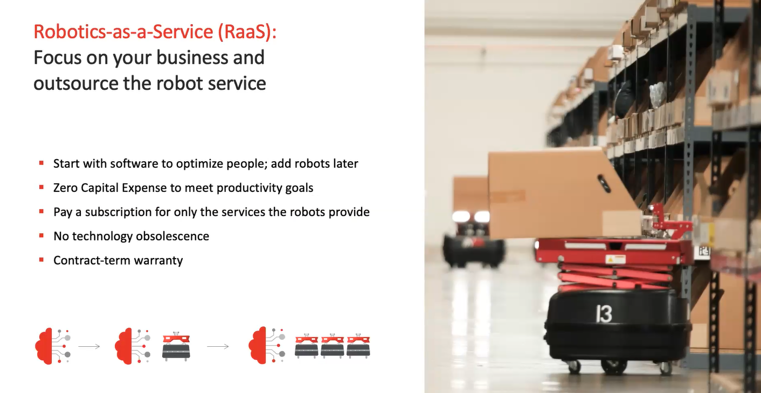
With RaaS, you are essentially seeing your automation provider as a partner and contracting with them to deliver agreed levels of productivity in return for a monthly agreed fee. It is the supplier’s obligation to provide the robotics resources necessary to deliver, and it is therefore in their interests to make the system as efficient as possible, hence the partnership approach.
A key driver of RaaS is RoI as it removes the need for high initial capital investment and becomes an Opex solution. Your monthly cost will be less than your labour savings from day 1. This is ideal for 3PLs as they can confidently factor this into client contracts, and not have to carry any long term risk.
Other benefits of RaaS include future proofing and flexibility – you are not left with a set of obsolete technology robots at the end, and it is simple to add-on more robots for specific ‘peaks’ of activity (e.g. Black Friday).

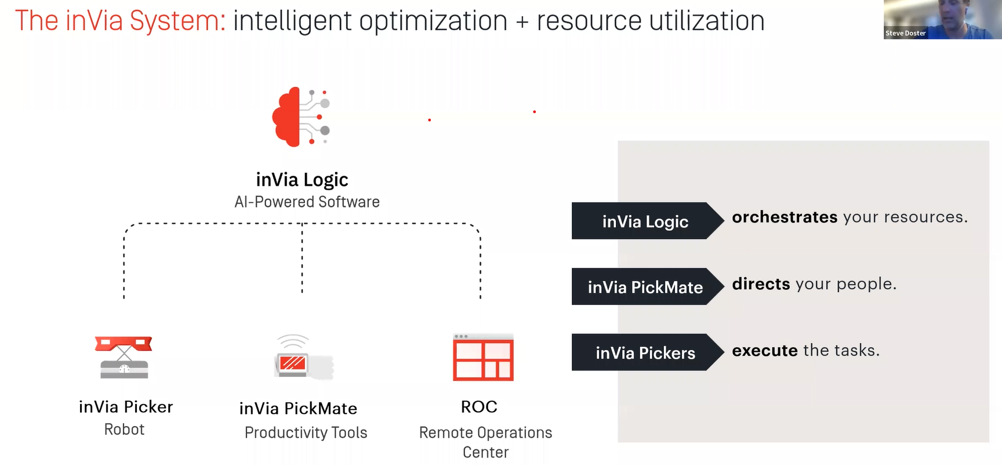
Warehouse operators are experts at distribution and fulfilment – inVia looks after the robotics.
inVia’s CRAWL – WALK – RUN strategy facilitates the change management required to effectively adopt a robotics solution.
Step 1: Optimise what you have already got using inVia Logic software – people and inventory.
Step 2: Test the water with small robotic implementations, proving their effectiveness and understanding their impact on working practices and the workforce.
Step 3: Gradually roll out robotics until all orders are going through the robotic grid.
Case Studies
The following illustrate the benefits of implementing the inVia solution:
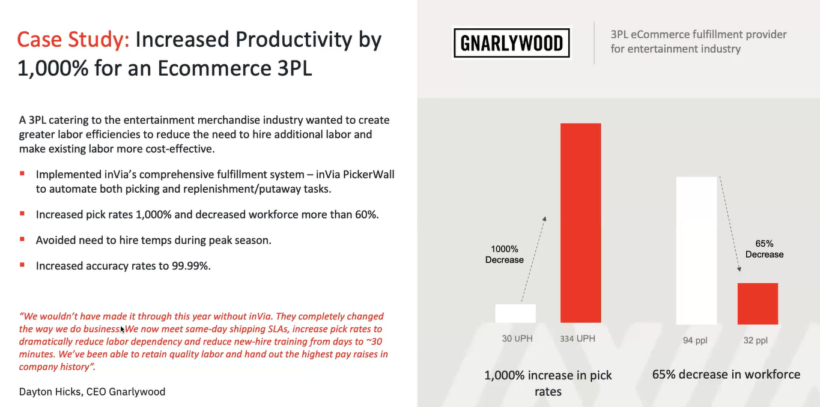
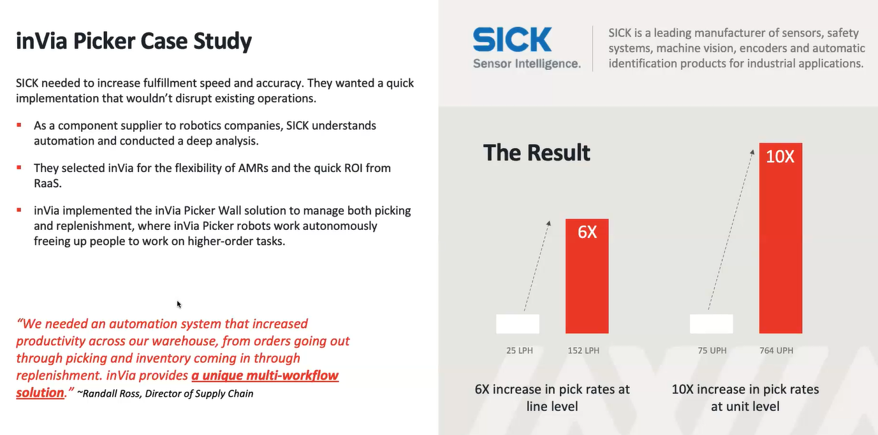
Phil Regan - AMR
Why partner with inVia Robotics?
AMR is focussed on identifying and delivering innovative technology solutions to the supply chain sector. The team has extensive experience in software and the supply chain, and expertise in new business development and project management.
We undertook a detailed review of the UK market for supply chain robotics on behalf of a client, and it soon became clear that inVia offered something unique in the warehouse fulfilment sector. We were impressed with the adaptability of the inVia Logic software underlying the robots, and the fact that the robots were designed with the end-user in mind.
The AMR team have experience in large change management projects and understand the frustration of long-term paybacks. With inVia, deployments are within a few months, and payback almost as fast with their RaaS model. Furthermore, the inVia solution is not limited to greenfield sites – as long as you can push a cart around, you can utilise an inVia picker robot.
The other point we picked up early on is that inVia can work on mezzanine floors, a feature much more prevalent in the UK as opposed to the US. The robots are lighter than their competitors.

How the partnership works
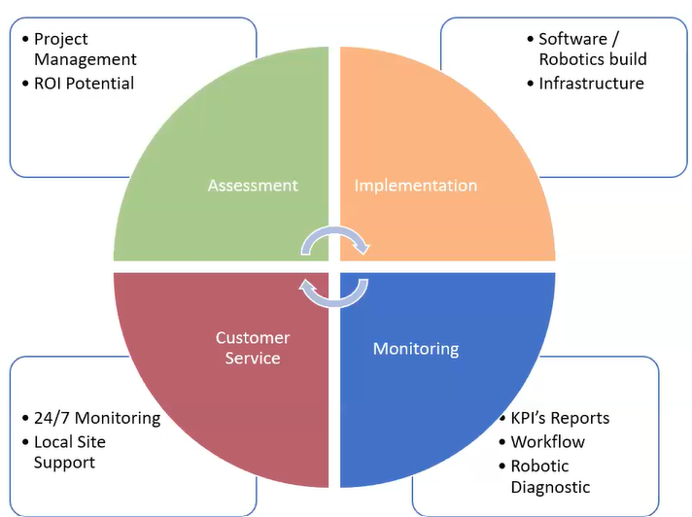
AMR have a project management team in the UK and a mirrored relationship with the inVia team.
We are inVia’s feet on the ground during all stages:
- Working with the client to assess the suitability of their operation (e.g. flooring, racking, wi-fi etc) and to capture all the information necessary to design the solution and quantify the costs and benefits. We make sure that deployment will be successful
- Project managing the implementation and training the client’s key people.
- inVia’s 24/7 support gives you real time information on performance against key KPIs. AMR are there to respond to any issues that may occur that can’t be solved remotely
- AMR are also responsible for setting up the RaaS contract with the client.
……………………………………………………………………
Conclusion
Raas can certainly address some of the potential financial barriers to taking that first step into the world of warehouse automation. However, the critical first step is to decide on the right entry strategy.
If you are planning to grow rapidly without being constrained by labour availability, then you need flexibility and scalability – the inVia solution provides that.
Gain a competitive advantage.
If you want to be at the forefront of fulfilment automation and are interested in learning more about the inVia Robotics solution, please email me at Paul.brooks@amrsupplychain.com
AMR Supply Chain is the exclusive UK/EU partner of inVia Robotics.

